Basnett Street Nursery School
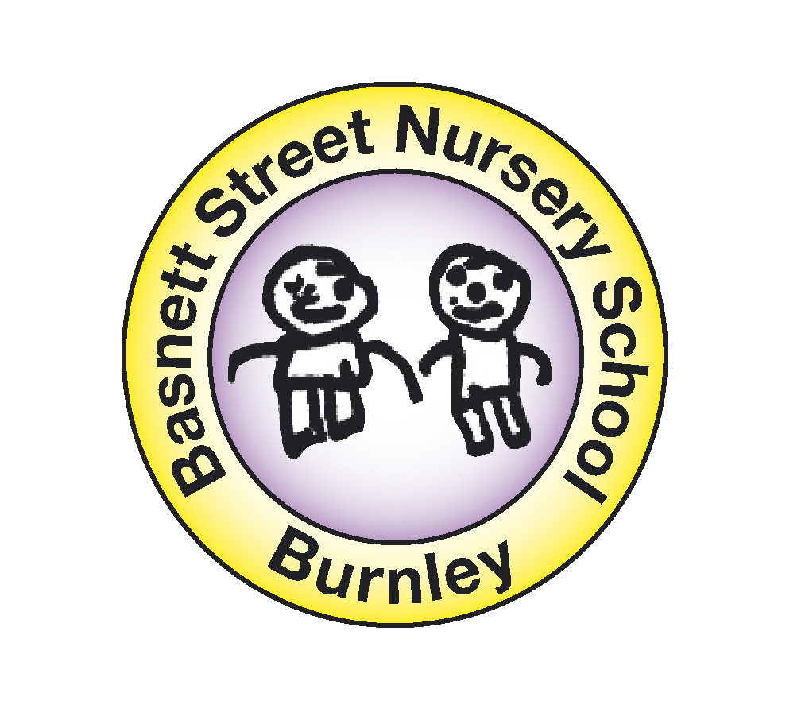
Admission Policy
Basnett Street is a Lancashire County Council Maintained Nursery School and caters for 106 children attending on a part-time basis. Children attend either 5 morning or 5 afternoon sessions weekly.
- Mornings are 8:45am to 11:45am
- Afternoons are 12:40pm to 3:40pm

The Education Committee of Lancashire County Council requires places to be allocated according to the following criteria, which are stated in priority order:
Admission Policy for maintained Nursery Schools and Nursery Classes within Community and Voluntary Controlled Schools
- Children in public care (looked after children) or those children at risk of becoming looked after.
- Children with statements for special educational needs (SEN) and those with exceptional/strong SEN reasons for attending a particular school/setting.
- Exceptional/strong medical, social, welfare reasons (associated with the child and/or the family) for attending a particular school/setting.
Please bear in mind that all nurseries can make provision for special educational needs and can also manage common medical conditions e.g. asthma, epilepsy and diabetes.
- Children who will have a sibling in attendance at the time of their admission.
- Parents/carers who provide evidence of training/education at a local establishment, working locally or established local childcare arrangements (at time of the child’s admission).
- Those living nearest the school/setting.

PLEASE BRING YOUR CHILD’S BIRTH CERTIFICATE
WHEN RETURNING COMPLETED APPLICATION FORM

Notes

- In relation to i), ii), iii), iv), and v) parents must provide the necessary evidence and contact names/e-mail/telephone numbers with their application.
- For criteria iv) siblings are defined as brothers, sisters, step brothers, step sisters, half brothers, half sisters, adopted and fostered children living with the same family at the same address.
- In relation to vi) measures will be in a straight line (centre of building to centre of building).
- Criteria vi) will be used as a tie break should there be oversubscription within any of the stated admission criteria.

In most cases children will be admitted to the nursery school or class of their parents’ preference. Occasionally, however, a school or class will receive more applications than there are available places. Parents will be able to seek provision elsewhere and can also request that their child’s name be placed on a waiting list for places at their preferred school or class. Should places become available then these will be offered in accordance with the published admission criteria and not on a first come first served basis.
Single Remaining Place – Additional Tie Break

If a single place remains available at a nursery school or class and the next application is for twins/triplets etc then flexibility will be exercised wherever possible to allocate places for both/all of the children. Individual nursery schools and classes must liaise with local authority if this situation arises.
Where a single place remains and there is more than one remaining applicant, an additional tie break may occasionally be required e.g. where there are two identical measures for the single remaining place. In these circumstances a random draw will determine which child will be offered the place.
In Relation to the extended provision and increased flexibility during the school term there may be the need for prior contact with individual applicants about their requested hours and/or pattern of provision. This may lead to negotiation and agreement about what is available at that setting. Referrals to other local providers as possible options may also be an outcome. In addition, shared provision may be suggested as a consideration in certain circumstances. Any discussions which are necessary will be aimed at meeting the needs of applicants by signposting provision at that setting and in the area as a whole and highlighting the overall strategy of flexibility.
Procedures

In each year group it is expected that a mixture of 3 and 4 year olds will be admitted.
Children should have reached their 3rd birthday by 31st August each year to be considered for admission.
Parents may make an application at any time, (however completion of the form DOES NOT guarantee a place).
The applications list will remain open until a date published each year by the LEA, (usually early January).
Additional Information

The School’s intake is generally in the autumn term each year (September) with further intakes in the spring (January) and summer (April) terms only if places become available or are unfilled from the autumn term.
We operate a ‘staggered entry’ policy in order to provide a suitable settled routine and environment for all the children being admitted. Individual admission dates are given during the months of September to October inclusive. Admission dates for children with special educational needs may be determined individually in consultation with parents and other agencies.
Places will be allocated to morning or afternoon sessions as they are available. Parents may only state a PREFERENCE on the application form and this cannot be guaranteed. A minimum of 3 terms attendance is usual. Children are expected to attend regularly as any unsatisfactory attendance may lead to the withdrawal of the place. A child CANNOT have a place at more than one LEA Nursery School or Class.
Attendance at any LEA Nursery School DOES NOT guarantee a child a place at any given Primary School. It is a parent’s responsibility to apply to the Primary School of their choice at the appropriate time.
A standard application form must be completed and this allows parents to provide any educational, medical, and social or welfare advice and any other reasons for requesting admission. Additional information may be requested, where it is clearly relevant, to assist in the consideration of applications.
It is a parent’s responsibility to inform the school of any changes needed to the information given on the application form.
Where a child moves into the area, having previously been in attendance at an LEA Nursery School or Class, consideration will be given to offering that child a place at the next intake. This will not be at the expense of special needs, medical or social cases.

The School Admissions Panel

The Head teacher, the Chair/Vice Chair of Governors and one other nominated Governor from the School Admissions Panel. Referring agencies may be invited to join the panel as appropriate. When there are more applications for places, than places available, the Panel will meet to consider all applications against the criteria stated above and allocate places accordingly. This usually takes place in the spring term to allocate places for the next autumn. All parents are informed as soon as possible whether or not a place has been allocated for their child. The names of unsuccessful applicants are kept on a reserve list for further consideration should a place become available.
Appeals
There is no formal appeals mechanism for Nursery Schools, but the Governing Body will make arrangements to review decisions where requested and where substantial new information becomes available.
Consultation, Monitoring and Evaluation

The Governing Body, Headteacher and all staff have been involved in the writing of this policy and will monitor and evaluate it annually.

